 [Translated from Chinese (Simplified) to English - www.onlinedoctranslator.com](https://www.onlinedoctranslator.com/en/?utm_source=onlinedoctranslator&utm_medium=docx&utm_campaign=attribution)

**contents**

contents

1. Executive summary 3

1.1 Game overview 3

1.2 Technical summary 3

1.3 Development division 3

2. Core design 5

2.1 The use of hardware 5

2.2 Control logic and script design 5

2.2.1 VR player control 5

2.2.2 The first level "virtual world" enemy activities 8

2.2.3 AR player control 10

2.2.4 Enemy's activities in the second stage "AR World" 12

2.2.5 Main Animator Controller 16

3. Product Evaluation 17

3.1 Game Engine 17

3.2 Target platform 17

4. Schedule 17

4.1 Development plan 17

4.2 Milestones 18

5. Working environment 18

5.1 Local collaboration 18

5.2 Local integration 19

6. Levels 19

6.1 Start menu 19

6.2 The first level of the virtual world 20

6.3 Level 2 AR World twenty one

6.3 Resource list twenty two

7. Problems with the use of Vuforia twenty three

7.1 NavMesh cannot be accurately positioned on ImageTarget twenty three

7.2 Try to solve 25

7.3 Solution 25

#### Game development team

Producer

# Lei Junjie

important

This technical design document is only used for software engineering of East China University of Science and Technology

If you have any copyright issues, please contact the relevant personnel.

# 1. Executive summary

## 1.1 Game overview

The "Justice Killer" game is a third-person role-playing game based on a computer virtual world and an AR perspective. The protagonist of the game is a killer. In the game, when the killer's story begins, he is in a virtual world of ice and snow. In order to find a way to survive, he must find and deal with the evil enemies in the virtual world. In the first level, in addition to the hands and feet, the player can use the picked gun to design the enemy, and use these three attack methods to attack the enemy to get points. The player can enter the second level after dealing with the three enemies in the first level. There is only one BOSS in the second level, which is a cute evil mouse. The player's equipment will all fall at this time, and the player needs to rely on his own hands. Attack the rat boss with his potion and his own hands and feet. After defeating the rat, the player can successfully pass the level.

## 1.2 Technical summary

The "Justice Killer" game was developed using the Unity engine and was completed by a team of 2 people in about 3 weeks. The modeling resources of the 3D resources in the first level use the lowpoly environment from aigei to model the prefab and its characters. The AR system in the second level uses the Vuforia8 of the Unity platform and the enemy modeling from Maximo and the corresponding action animations. The production cost of the entire game product is mainly labor cost. The main reward is the learning of game design and the absorption of relevant experience.

The game will be released to the PC and Android platforms at the same time. Minimum equipment requirements:

PC, MAC and LINUX stand-alone version

Operating system: Windows XP SP2 or above, Mac OS X 10.8 or above, Ubuntu 12.04 or above, SteamOS or above

Graphics card: at least support DX9 (Shader Model 2.0); graphics cards produced after 2004 are basically acceptable

ANDROID

ANDROID OS version 2.3.1 or above

Support NEON ARMv7 (Cortex) CPU or Atom CPU OpenGL ES 2.0 or above

## 1.3 Development division

There are two development members of the team: Zheng Qingwen (student number 10161831) and Lei Junjie (student number 10161832), the two cooperated and helped each other, and jointly completed the game development project of "The Messenger of Justice". The code written by the two They are all compiled by themselves, and the specific division of labor is as follows:

**Zheng Qingwen:**

Proposed the overall idea of ​​the killer game, mainly responsible for the design of the start menu and the first level part, as well as the operation and logic scripts used therein, mainly related to the player's attack control logic; and participated in the writing of the level design part of the document.

Script writing:

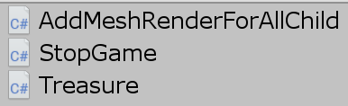

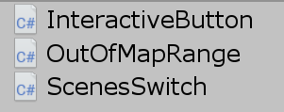

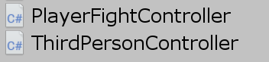



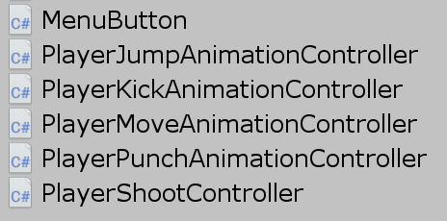

**Animation Controller:**



Scene construction:





**Lei Junjie:**

Put forward the idea of ​​using AR, mainly responsible for part of the UI, the design of the second level AR level and the corresponding operation and logic scripts, and the integration of the game. It mainly involves the enemy’s attack and the player’s control logic and participates in the main document write.

Script writing:



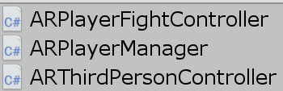

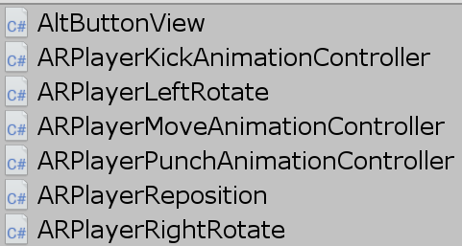



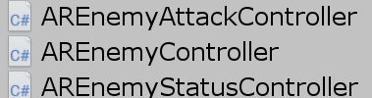

**Animation Controller:**



Scene construction:

andPartial modification

# 2. Core design

## 2.1 hardwareusage of

The team needs two laptops with windows system as the main hardware platform for game development and resource creation, as well as other hardware the team already has.

The mobile experience of this game requires an Android tablet or mobile device.

## 2.2 Control logic and script designcount

The following introduces the main software scripts used in the development of the "Justice Killer" game. However, not all team members will use all the software scripts in the following list. The specific selection of scripts is mainly determined by the parts designed and written by the members.

### 2.2.1 VR player control

**Introduction to Logic**

(1) Player control system

This part mainly allows the player to operate through the on-screen buttons from the third-person perspective. The controller will change the character's motion state and correspondingly change the animation state machine to control the character's movement, jumping and attack. Because each state needs to be processed separately and made into corresponding button components, we wrote this system ourselves.

When using Unity’s own CharacterController component directly, the character does not show the effect of gravity. When we add a rigid body component to the character, it will pass through the Collider directly. For this we wrote the character’s jump controller. The core of the jump controller is how to detect the character's contact with the ground and make it have jumping inertia. Of course, we can also achieve more complicated things, such as detecting the obstruction above the head to avoid mold penetration, and considering the slope of the ground to allow the character to slide.

(2) Player combat system

This part is mainly responsible for monitoring the character's health bar, energy and attack status, etc., to realize the interaction between the player and the scene, characters, objects, etc. The most important way to interact with the scene is to use the trigger of the collision body. The design method is to set a sensor object for each interaction. When the sensor of the character detects a collision with the corresponding object, the relevant interaction method is implemented. Based on this, the invisible interaction method can be changed to tangible, for example, the player's attack range can be set as a collision box.

**Part of the key code**

(1) Play**erFightController.cs**

void Update()

{

if (Dead || Stop)

return;

if(HP.x + MAX <1f)

{// Player's health bar is insufficient

Dead = true;

PropView[3].text = "You Lose";

action.SetBool("Dying", true);

}

now += Time.deltaTime;

if(now >= 1f)

{// Physical strength is automatically restored every second

ChangeMP(0.002f);

now = 0;

}

if(Plus)

{// add bullet

PropCount[2] += 10;

BulletCount = PropCount[2];

Plus = false;

}

if(Lose)

{// shooting

if(PropCount[2]> 0)

PropCount[2]--;

Lose = false;

BulletCount = PropCount[2];

}

UpdateUIState();

}

(2)**PlayerJumpAnimationController.cs**

void Update()

{

if (PlayerFightController.isStop())

return; // The game stops

vector.y = Vy;

Vg += 0.5f * Time.deltaTime; // Simulate gravity

Vy -= Vg; // change the vertical speed

float dy = motion.transform.position.y;

vector *= Time.deltaTime; // Theoretical falling distance

flag = motion.Move(vector);

dy = motion.transform.position.y-dy; // actual falling distance

if (vector.y <0f && dy-vector.y <0.001f)

Dy -= vector.y; // update the falling distance if the actual fall is equal to the theoretical fall

if (flag == CollisionFlags.Below)

{// touch the ground

if (Dy> 2f) // fall damage [2f-8f]

PlayerFightController.ChangeHP(-0.001f * Mathf.Exp(Dy));

Vy = 0f; Vg = 0f; Dy = 0f; // reset data

jumping = false;

action.SetBool("Jumping", false);

}

}

(3)**PlayerMoveAnimationController.cs**

void Update()

{

if (PlayerFightController.isStop())

return;

if (PlayerJumpAnimationController.jumping)

{// Use inertia in jumping

Vx += (Vx == 0f)? 0f: ((Vx> 0f)? -1f: 1f) * unit;

Vy += (Vy == 0f)? 0f: ((Vy> 0f)? -1f: 1f) * unit;

}

else

{

Vx = dx / 100f;

Vy = dy / 100f;

}

target.Set(Vx * Time.deltaTime, 0,

(Vy> 0.7f? 4f: (Vy> 0f? 1.5f: 1f)) * Vy * Time.deltaTime);

motion.Move(motion.transform.TransformDirection(target));

action.SetFloat("H", Vx);

action.SetFloat("V", Vy);

}

(4) PlayerPunchAnimationController.cs

void FixedUpdate()

{

if (PlayerFightController.isStop())

return;

if (punching)

{

now += Time.deltaTime;

if (now >= gap)

{// Attack frequency

punching = false;

action.SetBool("Punching", false);

}

}

}

### 2.2.2 The first level "virtual world" enemy activities

**Introduction to Logic**

Since the enemy mainly interacts with the protagonist, only one of the two interacting parties can be passive and the other can be active. Therefore, the enemy needs to detect the various states of the protagonist when interacting with the protagonist and make corresponding decisions. We use OnTriggerStay when detecting collisions and execute interactive code in it. For this, we need to set a time variable to control the frequency of interactive execution. After the enemy is killed, the model will disappear and drop items will be generated at the current location.

**Part of the key code**

**BossController.cs**

void Update()

{

if (dead)

return;

if (timer> 1.3f)

{// End of death animation

dead = true;

gameObject.SetActive(false);

transform.Translate(0f, 1f, 0f);

treasure.transform.position = transform.position; // display props

}

else if (timer >= 0f)

timer += Time.deltaTime;

else if (blood <= 0)

{// Defeat the character

action.SetBool("Hiting", false);

action.SetBool("Dying", true);

timer = 0f;

if (name.Equals("Boss3"))

text.text = "You Win!";

}

else if (!(PlayerPunchAnimationController.punching || PlayerKickAnimationController.kicking))

{// Under attack

if (shoot <= 0f)

action.SetBool("Hiting", false);

else

shoot -= Time.deltaTime;

}

}

void OnTriggerStay(Collider collider)

{

if (collider.gameObject.name.Equals("AttackRange"))

{// Enter the attack range

if (period >= 0f)

{

period += Time.deltaTime;

if (period <= 1.2f)

return;

}

if (PlayerPunchAnimationController.punching)

{// The protagonist hits a punch

blood -= 10;

period = 0f;

action.SetBool("Hiting", true);

}

else if (PlayerKickAnimationController.kicking)

{// The protagonist is kicking

blood -= 30;

period = 0f;

action.SetBool("Hiting", true);

}

else

{

period = -1f;

action.SetBool("Hiting", false);

}

}

}

### 2.2.3 AR player control

**Introduction to Logic**

The main control logic is:

1) The joystick on the left side of the interface controls the player's front, back, left, and right movements, but because the player's front, back, left, and right moves relative to his localPosition during AR control, this is due to the control logic of the first level virtual world and the second level AR world There is a difference, so in addition to the corresponding changes to the player's position control, the AR control has added clockwise and counterclockwise rotation controls for the player-controlled character, which relatively allows the player to better control his character.

2) There is also the player's offensive control of the enemy, which is completed by the ARNemyStatusController bound to the CylinderTrigger on the enemy.The enemy determines whether the player's attack range has entered its own attack range, and if it is, the enemy's HP will be reduced.

3) If the player dies, the enemy will eat the player's "corpse". The animation here is from Maximo.

**Part of the key code**

**ARPlayerRotate (take ARPlayerLeftRotate as an example):**

private void Update()

{

if(isPointerDown)

player.transform.RotateAround(player.transform.position, player.transform.up, -rotateSpeed);

}

public void OnPointerDown(PointerEventData eventData)

{

isPointerDown = true;

ami.SetBool("isRotating", true);

}

public void OnPointerUp(PointerEventData eventData)

{

isPointerDown = false;

ami.SetBool("isRotating", false);

}

public void OnPointerExit(PointerEventData eventData)

{

isPointerDown = false;

ami.SetBool("isRotating", false);

}

**ARPlayerManager (a singleton instance used to find the position of the player for the enemy):**

public class ARPlayerManager: MonoBehaviour

{ #region Singleton

public static ARPlayerManager instance;

void Awake(){

instance = this;

}

#endregion

public GameObject player;

}

**AREnemyStatusController (character "corpse" who eats the player):**

if (PlayerFightController.isDead()) {

EnemyAnimation.SetBool("isBiting", true);

}

if (blood <= 0) {

dead = true;

EnemyAnimation.SetBool("isGettingHit", false);

EnemyAnimation.SetBool("isDead", true);

text.text = "You Win!";

if (dead)

{

now += Time.deltaTime;

if (now >= gap)

{

dead = false;

EnemyAnimation.SetBool("isDead", false);

EnemyAnimation.SetBool("isGameEnded", true);

}

}

}

### 2.2.4 Enemy's activities in the second stage "AR World"

**Introduction to Logic**

First, the enemy will get the player object created in 2.2.2, and then get the player's position, and then use the facetarget in the ARenemyController to face the player, and set the lookRadius in the ARenemyController, which is the search distance. Within this distance, the enemy will search for the player. , And then use distance to calculate the distance to the player and set a stopping distance. If the position of the player to the enemy is greater than this stopping distance, the enemy will use the setDestination in the Navigation in Unity's own AI to approach the player and play Walking animation, when the enemy is just born, it will play a roaring action to improve the player's experience of the game atmosphere. When the player enters within the stopping distance, the enemy will start to attack. At this time, the ontriggerEnter in the attackAreaTrigger loaded on the enemy will be Start the attack processing on the player, determine whether the player is in the range, and if it is, start the attack and make the player drop blood.

**Part of the key code**

**AREnemyController (yelling at the player, approaching the player, attacking the player):**

void Update()

{faceTarget();

timer += Time.deltaTime; //The mouse has stood up

if (target == null)

return;

if (timer >=5.5f) {

float distance = Vector3.Distance(target.position, transform.position);

if (distance <= lookRadius)

{

agent.SetDestination(target.position);

if (distance <= agent.stoppingDistance)

{

//The current enemy has stopped and started attacking

//The enemy should face the player before attacking

faceTarget();

mouseAnimator.SetBool("isAttacking", true);

}

else {

faceTarget();

mouseAnimator.SetBool("isAttacking", false);

}

}

else

{

mouseAnimator.SetBool("isAttacking", false);

}

mouseAnimator.SetBool("isWalking", true);

}

}

void faceTarget()

{

Vector3 direction = (target.position-transform.position).normalized;

Quaternion lookRotation = Quaternion.LookRotation(new Vector3 (direction.x, 0, direction.z));

transform.rotation = Quaternion.Slerp(transform.rotation, lookRotation, Time.deltaTime*5f);

}

**AREnemyAttackController (the attack causes the player to deduct blood):**

void OnTriggerEnter(Collider other) {//Start timing when the player enters the mouse attack range

time = 0;

}

void OnTriggerExit(Collider other)

{//The time starts when the player enters the range of the mouse attack

time = 0;

}

void OnTriggerStay(Collider other) //Timer

{

time += Time.deltaTime;

index = index + 1;

if (index == 50)

{

s_index = s_index + 1;

index = 0;

}

if (playerAnimator.GetBool("isAttacking")) {//If you are attacking

if (time >= 1) // hit the player

{

if(!playerAnimator.GetBool("isGameEnded"))

PlayerFightController.ChangeHP(-0.025f); //Heat deduction

//PlayerFightController.ChangeHP(-1f); //Heat deduction

time = 0; }}}

**AREnemyStatusController (the enemy is attacked by the player):**

void OnTriggerStay(Collider collider)

{

if (collider.gameObject.name.Equals("AttackRange"))

{

Debug.Log("Enemy is getting attacked");

if (period >= 0f)

{

period += Time.deltaTime;

if (period <= 1.2f)

return;

}

if (ARPlayerPunchAnimationController.punching)

{

blood -= 10;

period = 0f;

EnemyAnimation.SetBool("isGettingHit", true);

}

else if (ARPlayerKickAnimationController.kicking)

{

blood -= 20;

period = 0f;

EnemyAnimation.SetBool("isGettingHit", true);

}

else

{

period = -1f;

EnemyAnimation.SetBool("isGettingHit", false);

}}}

### 2.2.5 Main Animator Controller

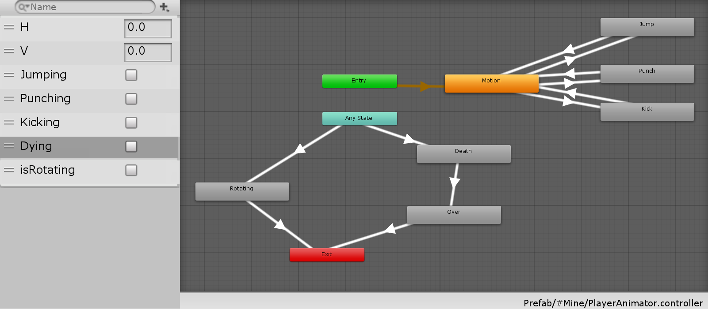

2-2-5-1 PlayerAnimatorController (player's motion animation controller)

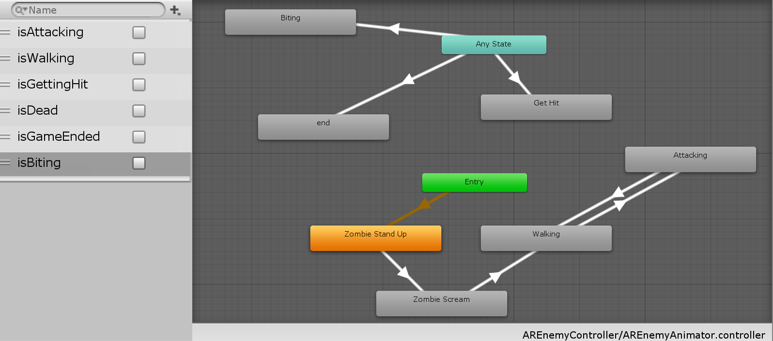

2-2-5-2 AREnemyController (an action animation controller for AR enemies

# 3.Product evaluation

## 3.1 Game Engine

Our game design project uses the Unity engine to produce. For the "Justice Killer" game, we need an engine that can create a new virtual scene to build the first level, and this engine should support the construction of the AR environment. We judge that Unity can be used More beautiful scenes and you can use Vuforia to set up the AR environment. In addition, Unity also supports the export of portable device installation packages. Because we also plan to use this game to support Android users, we chose Unity.

## 3.2 Target platform

The "Justice Killer" game will be released to PC and Android platforms. On the one hand, the original intention of this game is to enable developers to experience the game design process and design methods as well as the actual combat experience of related development, and to allow players to better experience our design ideas and support a variety of The use of the client, plus we also added screen size adaptation, so our game can be exported to the PC platform client or Android terminal. On the other hand, the Android platform is also a good target platform. This platform is more portable and is more conducive to the proliferation of the game itself. In addition, we have used AR as the basis of the second level of the game. If you play this game on the mobile terminal, players will have a better gaming experience.

# 4. Schedule

## 4.1 Development plan

|  |  |  |
| --- | --- | --- |
| name | The first two weeks of the three weeks of December 2019 | In the last two weeks of the three weeks in December 2019 |
| **Scene modeling** | Use the given prefab to complete the construction of the first level scene | Complete the second level of AR scene construction |
| **UI** | Build the start menu  Build the first level game player interactive UI | Build the game player interactive UI for the second level |
| **Animation**  **Controller** |  | Partial changes with PalyerAnimator |
| **script** | Realize the logic control of player activity and attack in level 1  Realize the interface control and interface sound effects of the start menu  Realize the control of enemy activities and item falling in level 1. | Realize the player's activity and attack logic control in level 2  Change the interface control logic of some menus  Realize the AI ​​and control logic of enemy Boss  Change part of Vuforia's Default script |

## 4.2 Milestones

|  |  |
| --- | --- |
| 2019.12.1 | The creativity and needs analysis is completed, and the game project design is started |
| 2019.12.8 | Menu and level 1 and the corresponding control script are designed |
| 2019.12.14 | AR level (level 2) completed  And the corresponding control script design is completed |
| 2016.12.19 | Complete version |

# 5. Working environment

## 5.1 Local collaboration

The members of this team come from a dormitory, and they will work together to complete the project. Therefore, we are in the process of developing the game

In, we will use chat tools or mobile storage devices to store and share documents, and use Unity Collaborate to maintain and synchronize projects to ensure that we can carry out game iterative development work in a normal and orderly manner.

## 5.2 Local integration

Since level 1 and level 2 were developed separately, the project eventually needed to be merged, and the two parties actively assisted in the final completion of the merger of the complete project.

# 6. Levels

## 6.1 Start Menu

The first thing you enter after entering the game is the following menu:

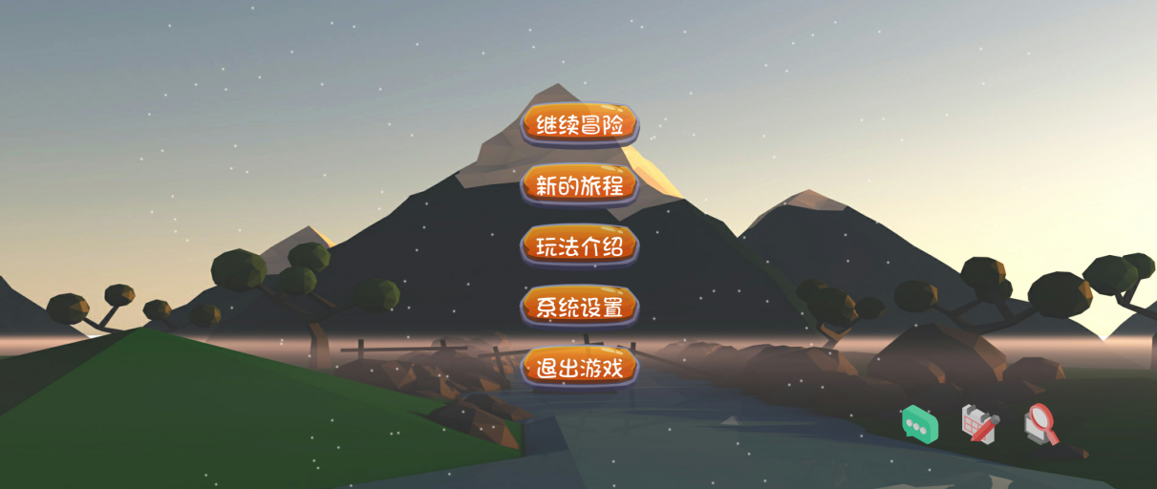

Figure 6-1-1 Start menu

There are scene music in the start menu, and there are multiple control options, among which the new journey can choose the level, as shown in Figure 6-2.

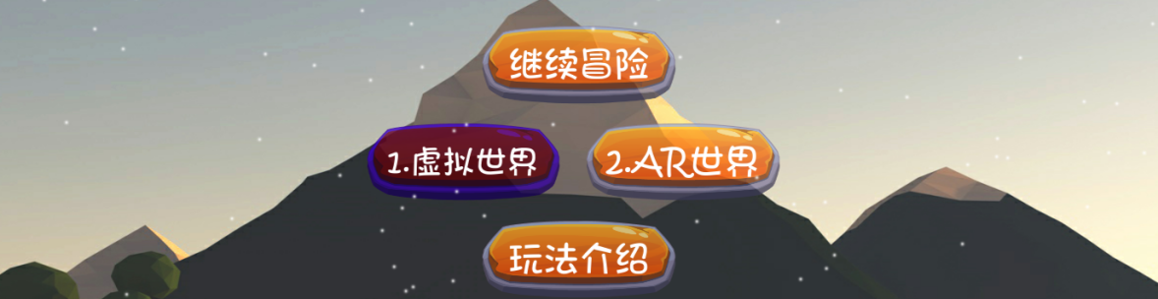

Figure 6-1-2 Level selection

In addition to the start menu, there is also a snowflake special effect we designed to improve the look and feel of the screen and make the player have a better experience.

## 6.2 The first level virtual reality

The killer of justice will appear on the edge of the virtual scene. Players need to find three enemies to be dealt with in the designed map, and attack the enemies, and then they can pass the level. The scene, map and attack method are shown in Figure 6 2-1 to Figure 6-2-3.

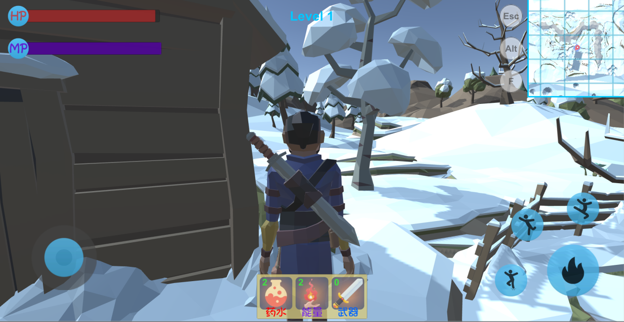

Figure 6-2-1 The first level map

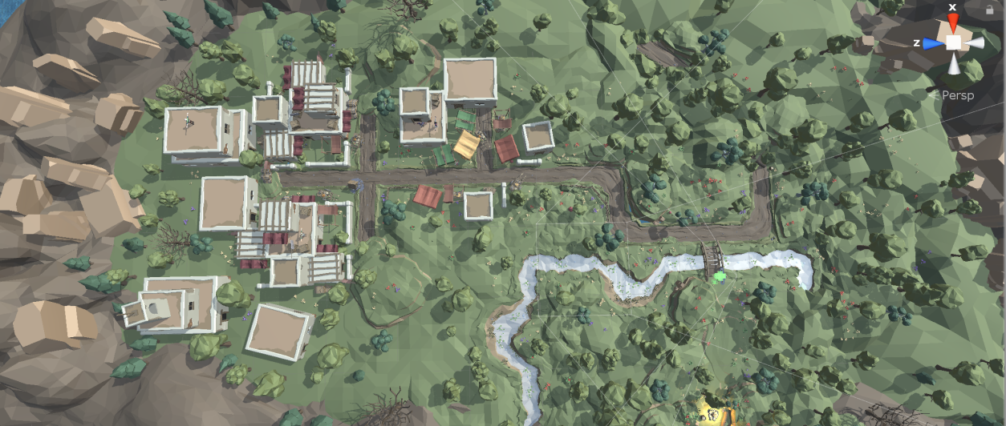

Figure 6-2-22 The map of the first level

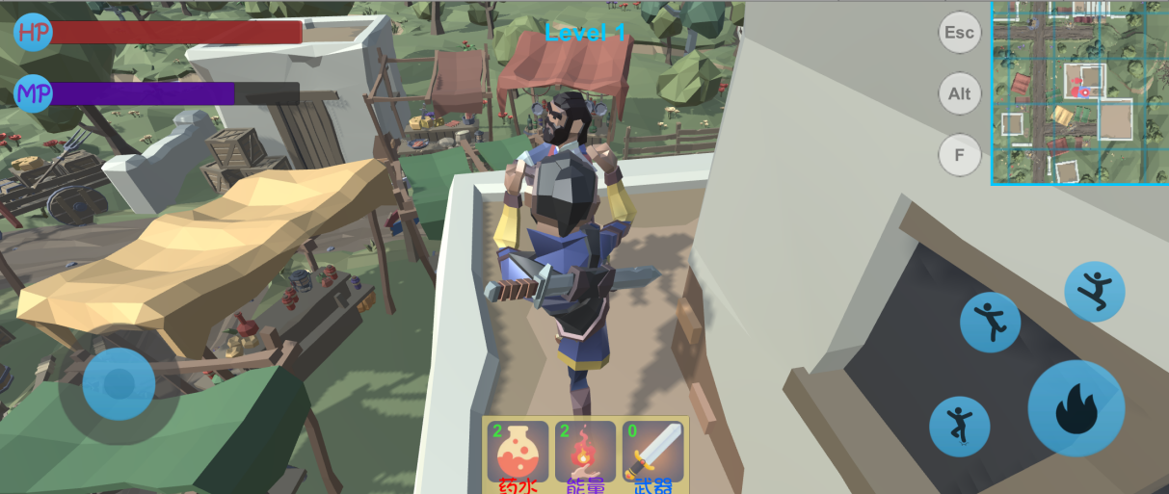

Figure 6-2-3 Attacking the enemy

## 6.3 NSSecond pass AR world

After opening the camera access permission on the Android side, because Vuforia's plane finder function does not work well here, we still use the marker recognition method. We use a playing card as our identification object, and the player can complete the first level. After that or directly from the main menu, choose to enter the second level. The second level is not as big as the first level. The main scene is the real world scene found by the AR camera. The second level and the player control are shown in Figure 6-3. -1 to 6-3-3.

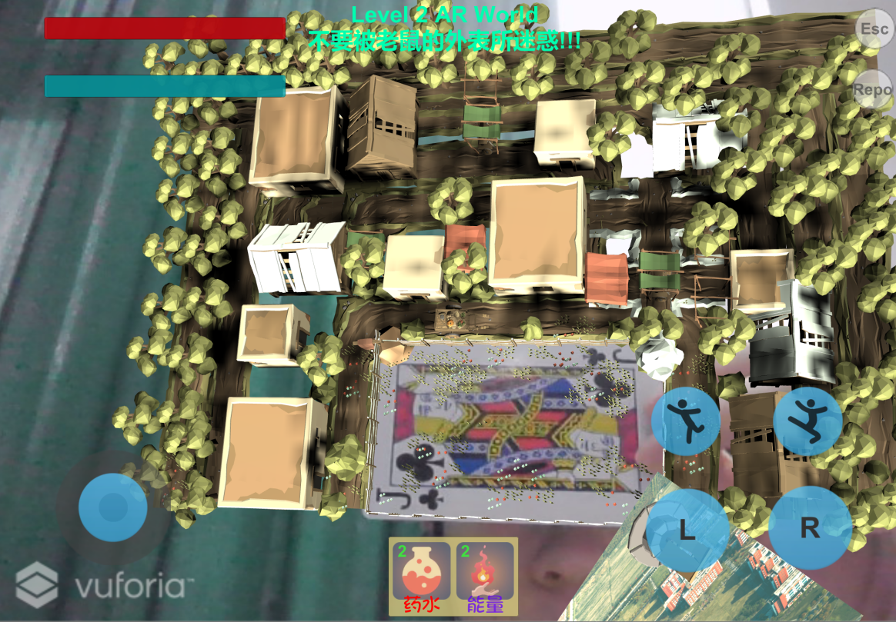

Figure 6-3-1 The overall scene of the AR world (the playing cards are our AR recognition Marker)

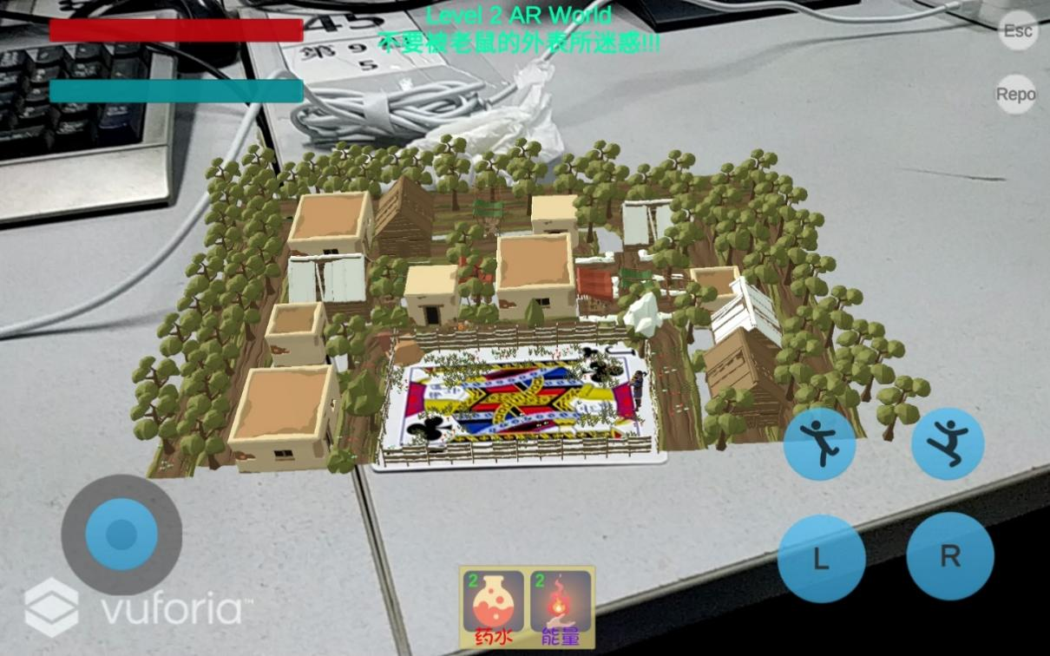

Figure 6-3-2 Player control (screenshot of Xiaomi tablet on Android device)

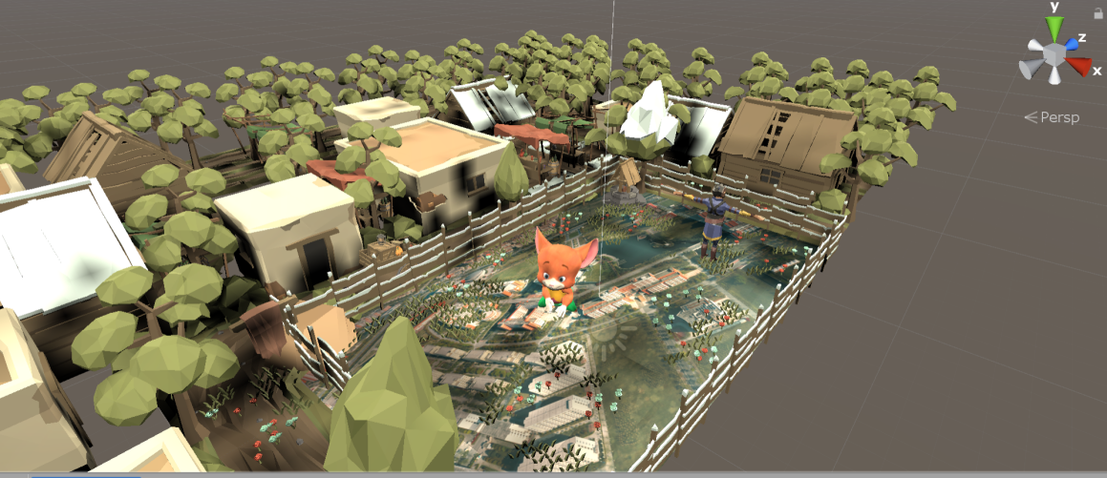

Figure 6-3-2 Setting up the scene

## 6.3 Resource list

|  |  |
| --- | --- |
| Player | Assassin image |
| enemy | In the first level, there are three Lowpoly enemies similar to the player's assassin image and the corresponding active and passive animations; in the second level, a mouse image from Maximo and animations such as zombie walk, shout, punching, hit reaction, etc. are used. |
| ally | sheep |
| environment | Built by Lowpoly environment prefab  And Vuforia's Targetimage recognition module |

# 7. Problems with the use of Vuforia

## 7.1 NavMesh cannot be accurately positioned on ImageTarget

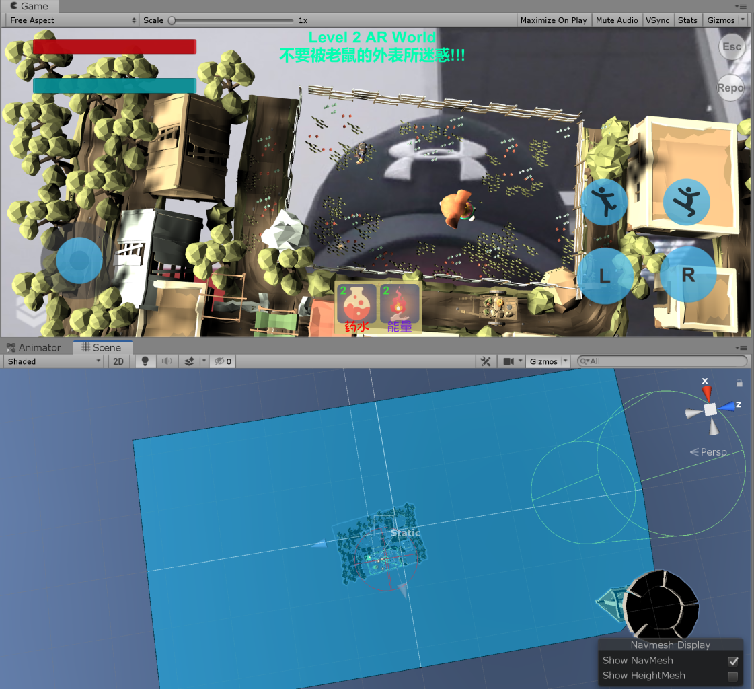

Figure 7-1-1 NavMesh is positioned under the scene

As shown in Figure 7-1-1, because the enemy mouse uses the Setdestination (code shown in Figure 7-1-2 below) under the use of NavAgent and NavMesh to locate the position of the player character, this is not used on the PC side It can be used when vuforia is tested. Using Navagent's stopping distance can also automatically set the position where the enemy stops in front of the player and then starts attacking. After Lei Junjie sets the navigation bake, the enemy and the player can attack each other. ongoing.

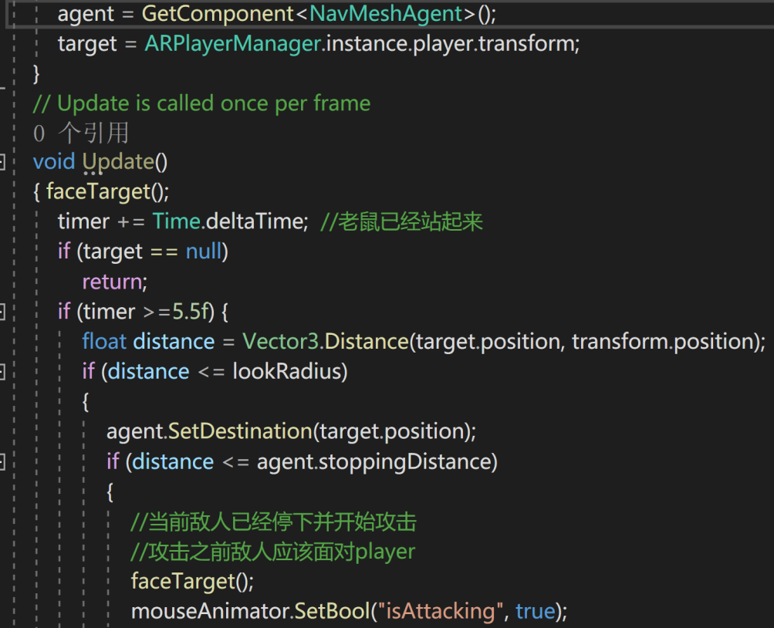

Figure 7-1-2 Use SetDestination to track and attack the player's position by the enemy

However, the problem occurred after using vuforia, and the NavMesh positioning as shown in Figure 7-1-1 failed. As a result, the mouse did not have available NavMesh to walk when tracking the player, resulting in an error (Figure 7-1-3) .

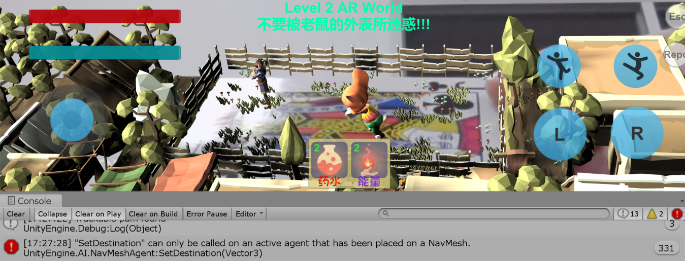

Figure 7-1-2 NavMesh error report

## 7.2 Try to solve

After trying various solutions and failed, I decided to start with NavMesh. Since the positioning of bake's NavMesh is always wrong, we tried to use runtime (that is, bake while running) NavMesh. After searching, I found it on github There are Unity official NavMeshSurface that has not yet joined Unity: <https://github.com/Unity-Technologies/NavMeshComponents>, Import these components to get new NavNeshComponents, as shown in Figure 7-2-1.

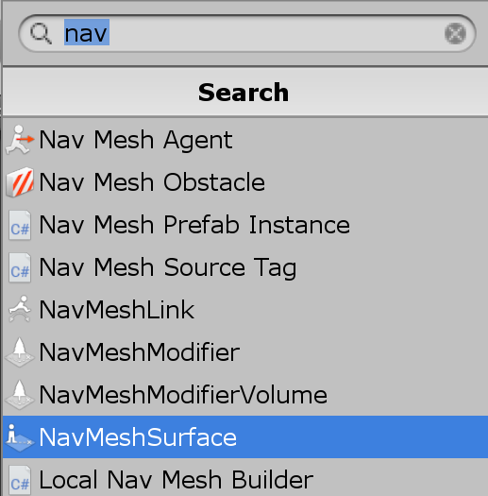

Figure 7-2-1 New NavMesh component

After adding the NavMeshSurface of real-time bake, the position of NavMesh is currently correct, as shown in Figure 7-2-2. However, the position of NavAgent now has a problem as shown in Figure 7-2-3, even if the Base Offset is adjusted to 73, the mouse There is still a large deviation from the player's plane, and the actual effect is extremely poor.

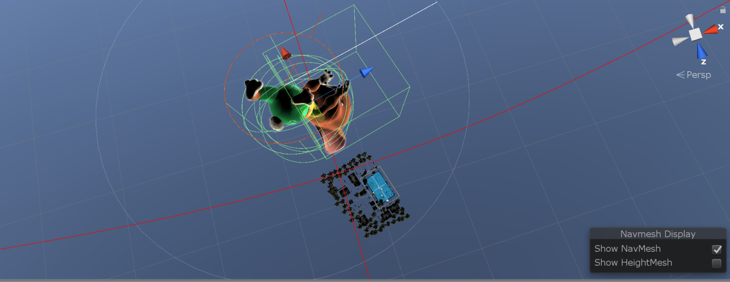

Figure 7-2-3 The position of NavAgent (the light blue part in the upper part of the figure is the current correct position of NavMesh)

## 7.3 Solution

The reason for using Navigation at the beginning is because for the future scalability of the game, if there are obstacles in the new level scene in the future, then the enemy's AI will behave naturally, but in order to solve the urgent need (the scene was moved three days before submission) This problem was discovered in the final test in AR), and finally decided to build a new way to track players, which can avoid the use of NavMesh. The built enemy operation script is as follows:

public class AREnemyController: MonoBehaviour

{

public float lookRadius = 10f; //The enemy is looking for the player in a certain range

float timer;

Transform target;

//NavMeshAgent agent;

public Animator mouseAnimator;

private float speed = 0.09f;

private float stoppingDistance =0.16f;

// Start is called before the first frame update

void Start()

{

timer = 0f;

// agent = GetComponent<NavMeshAgent>();

target = ARPlayerManager.instance.player.transform;

}

// Update is called once per frame

void Update()

{faceTarget();

timer += Time.deltaTime; //The mouse has stood up

if (target == null)

return;

if (timer >=5.5f) {

float distance = Vector3.Distance(target.position, transform.position);

if (distance <= lookRadius)

{// agent.SetDestination(target.position);

OntoDestinationJJ(target.position);

//if (distance <= agent.stoppingDistance)

if (distance <= stoppingDistance)

{//The current enemy has stopped and started attacking, And attackThe enemy should face the player before

faceTarget();

mouseAnimator.SetBool("isAttacking", true);

}

else { faceTarget();

mouseAnimator.SetBool("isAttacking", false);

}}

else

{mouseAnimator.SetBool("isAttacking", false);

}

mouseAnimator.SetBool("isWalking", true);

}

}

void faceTarget()

{

Vector3 direction = (target.position-transform.position).normalized;

Quaternion lookRotation = Quaternion.LookRotation(new Vector3 (direction.x, 0, direction.z));

transform.rotation = Quaternion.Slerp(transform.rotation, lookRotation, Time.deltaTime*5f);

}

void OnDrawGizmosSelected()

{Gizmos.color = Color.red;

Gizmos.DrawWireSphere(transform.position, lookRadius);

}

void OntoDestinationJJ(Vector3 targetPostion)

{

if (Vector3.Distance(mouseAnimator.transform.position, target.position) >= stoppingDistance) {

mouseAnimator.transform.position = Vector3.MoveTowards(transform.position, targetPostion, Time.deltaTime * speed);

}}}

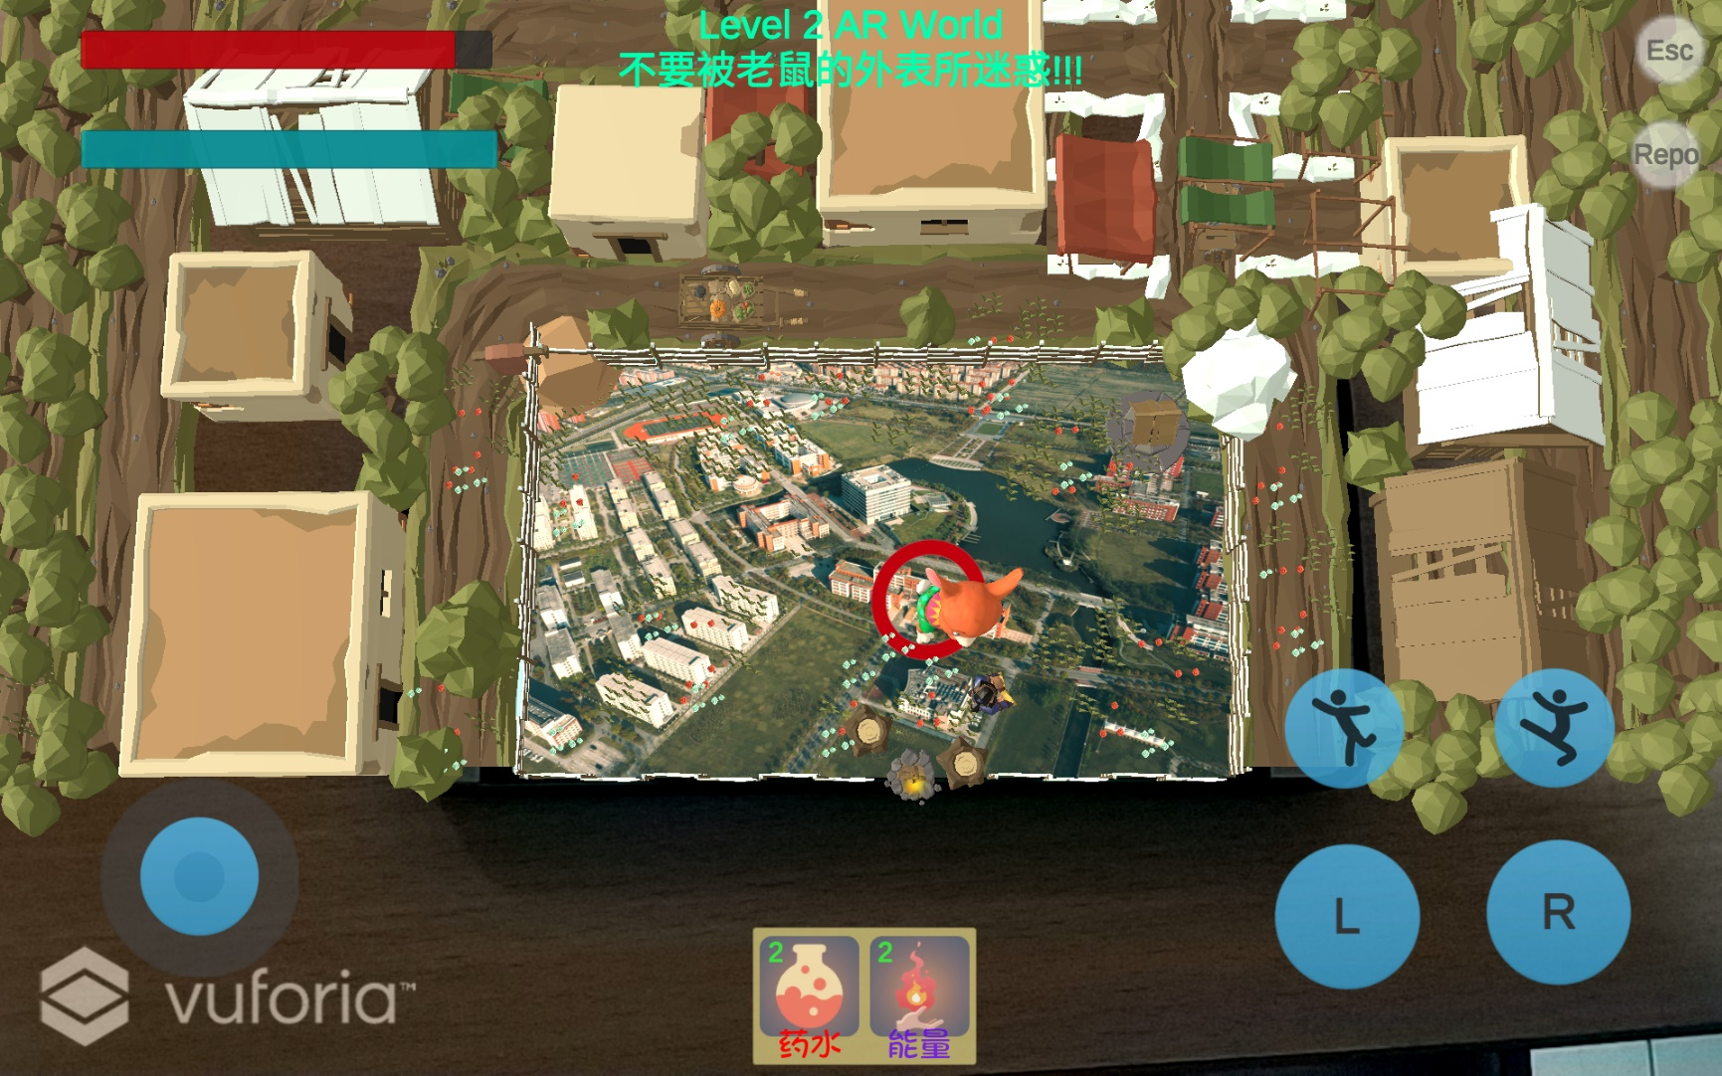

Figure 7-3-1 The final successful effect (the red circle in the mouse is the blood bar)